
Sreenidhi Institute of Science and Technology
Regulations:
A15
(An Autonomous Institution)
Code No: 5A304 Date:8-Dec-16(FN)
B. TECH. II-Year I-Semester Examinations, Nov/Dec 2016 (Regular)
CIRCUITS AND NETWORKS – II (EEE)

Time: 3 Hours Max. Marks:75
Note: a) No additional answer sheets will be provided.
b) All sub-parts of a question must be answered at one place only, otherwise it will not be valued.
c) Assume any missing data.

Part - A
Max.Marks:25

Answer all QUESTIONS
      - Write down relation between line and phase voltages and currents in star and delta connected system? [3M]
      - Define time constant? Write the time constant for series RL and series RC circuit? [3M]
      - Explain the restrictions of pole zero locations for driving point functions? [3M]
      - Write down the condition for Reciprocity and symmetry in h-parameter network [3M]
      - What is a filter? Define band, stop band and cutoff frequency? [3M]
      - Write any two Properties of Fourier transforms? [2M]
      - Prove that the sum of all three phase voltages at any instant is zero? [2M]
      - Draw the equivalent network of a two port network in terms of Y parameters? [2M]
      - What is the characteristics impedance equation for symmetrical unbalanced T-section? [2M]
      - Obtain voltage transfer function of RLC series network? [2M]

Part – B
Max.Marks:50

ANSWER ANY FIVE QUESTIONS. EACH QUESTION CARRIES 10 MARKS.

1. a) A 3-phase balanced delta connected load of (4+j8)ohms is connected across 400V,
3-phase balanced supply. Determine the phase currents and line currents. Assume the
phase sequence to be RYB ?
b) Explain the measurement of three phase active power by using two wattmeter method?

2. a) Derive an expression for DC transient response of series RL circuit by using differential approach method?
b) For the circuit shown in below fig. Find the current equation when the switch is opened
at t=0.

100v
–
–
+
+
5 Ω
10 Ω
20 Ω
I
10 I
5 μf

3. a) List the necessary conditions for Transfer functions?
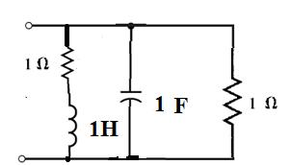
b) Find the driving point impedance of the network shown in the below fig:

4. a) Obtain ABCD parameters in terms of Z parameters?
b) Determine the Z, Y and H parameters of the network shown?

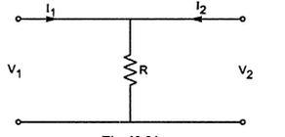

[5+5]

5. a) Design a T and π section constant-K high pass filter having cut off frequency of 12kHz and nominal impedance Ro = 500Ω. Also find its characteristic impedance?
b) Explain the steps involved in composite filter design.

6. a) Explain about
i) Even function symmetry
ii) Odd function symmetry
iii) Half wave symmetry.?
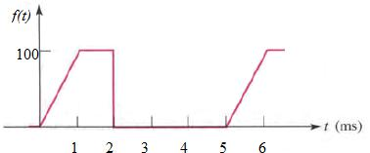
b) Obtain the trigonometric Fourier series of following waveform.

7. a) Determine the line currents in an unbalanced star connected load supplied from symmetrical 3-phase 440V system. The branch impedances are Z_{R}=4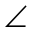30⁰, Z_{Y} =1045⁰ and Z_{B}=1060⁰ . The phase sequence is RYB?
b) Derive an expression for DC transient response of series RC circuit by using Laplace transform method?

8. a) Show that when two 2-port networks N₁ and N₂ are connected in parallel, then the
Equivalent Y-parameters of the combined network is the sum of Y-parameters of each
Individual 2-port network?
b) Explain Low pass, High pass, Band pass, Band elimination Prototype filters ?

-- 00 -- 00 --

